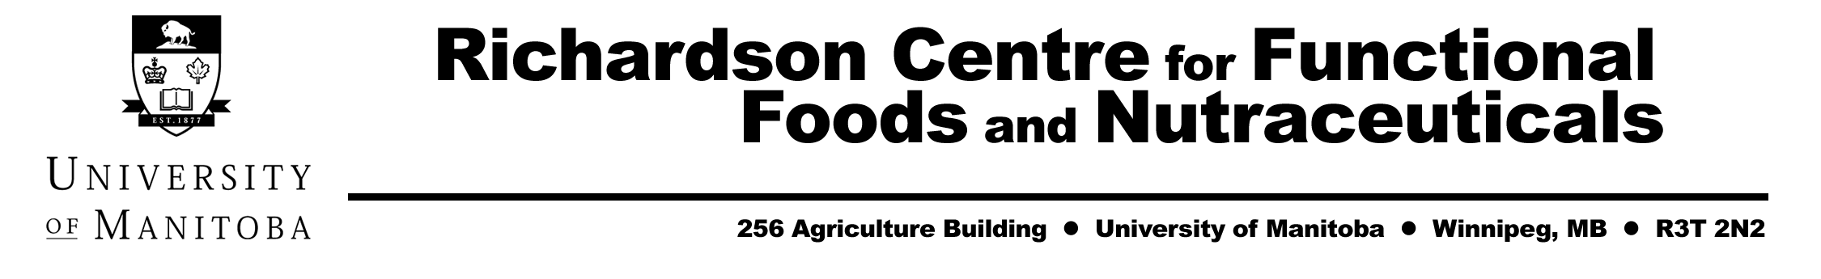
Canada as a Global Functional Food Ingredient Innovator

October 6 and 7, 2003

The Fairmont Hotel
Winnipeg Manitoba

The Canadian nutraceutical, natural health product (NHP) and functional food industry has garnered a great deal of attention and enthusiasm on the part of governments, the agri-food sector, health care and research communities in Canada for its significant potential to provide:

  - Diversification and market growth for Canadian agriculture and marine based industries
  - Increased economic development in Canada
  - Reduced health care costs for all Canadians
  - Improved health and well-being and disease reduction for all Canadians

The Western Canadian industry, in particular, is characterized by small and medium sized companies that are science-based and focused heavily on research and development to leverage health applications of value-added ingredients from basic agricultural commodities grown mostly in the region. The industry is moving increasingly to branding of its ingredients, with larger companies bringing the products to market. Functional food ingredient manufacturers face much different challenges than traditional food producers or supplement manufacturers in many aspects of product development, research and marketing.

This conference will attempt to address these issues through presentations by world renowned speakers as to “How to position Canada as a Global Functional Food Ingredient Innovator”.

The following topics will be highlighted over the two day period:

“What are consumers seeking in regard to functional foods and nutraceuticals?”

“The European experience with functional food ingredients”

“The US experience with functional food ingredients”

“Agriculture and functional food ingredients: New strategies for success”

“The role of science in the development of functional food ingredients”

“Herbs and botanicals as functional food ingredients”

“Using functional ingredients in beverages”

“Canadian regulations related to Natural Health Products”

“Canadian functional food ingredient supplier panel discussion: Opportunities and challenges facing the industry”

“Canadian functional food ingredient success stories: The science behind the products”

“Clinical research in functional foods in Canada”

“Commercialization and technology transfer – how to work with public research institutions and to move a product to market”

In addition, a trade show and poster session is being planned.

For more information, contact
Kelley C. Fitzpatrick
Marketing and Research Development Manager
Tel. 204-474-9713
Kelley_Fitzpatrick@umanitoba.ca

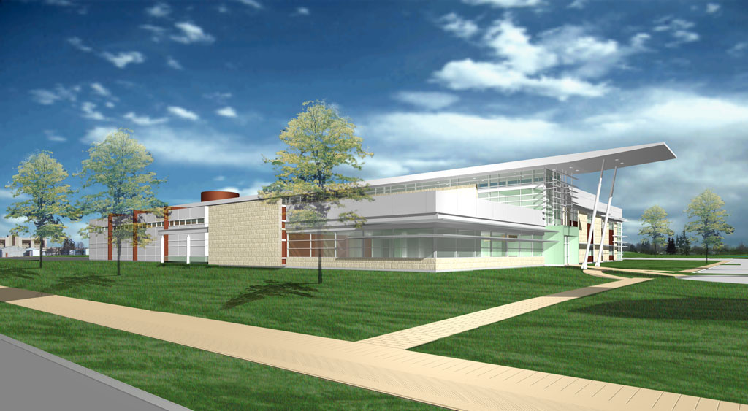

Architect’s rendering of the Richardson Centre for Functional Foods and Nutraceuticals at the
University of Manitoba’s SMARTpark.

